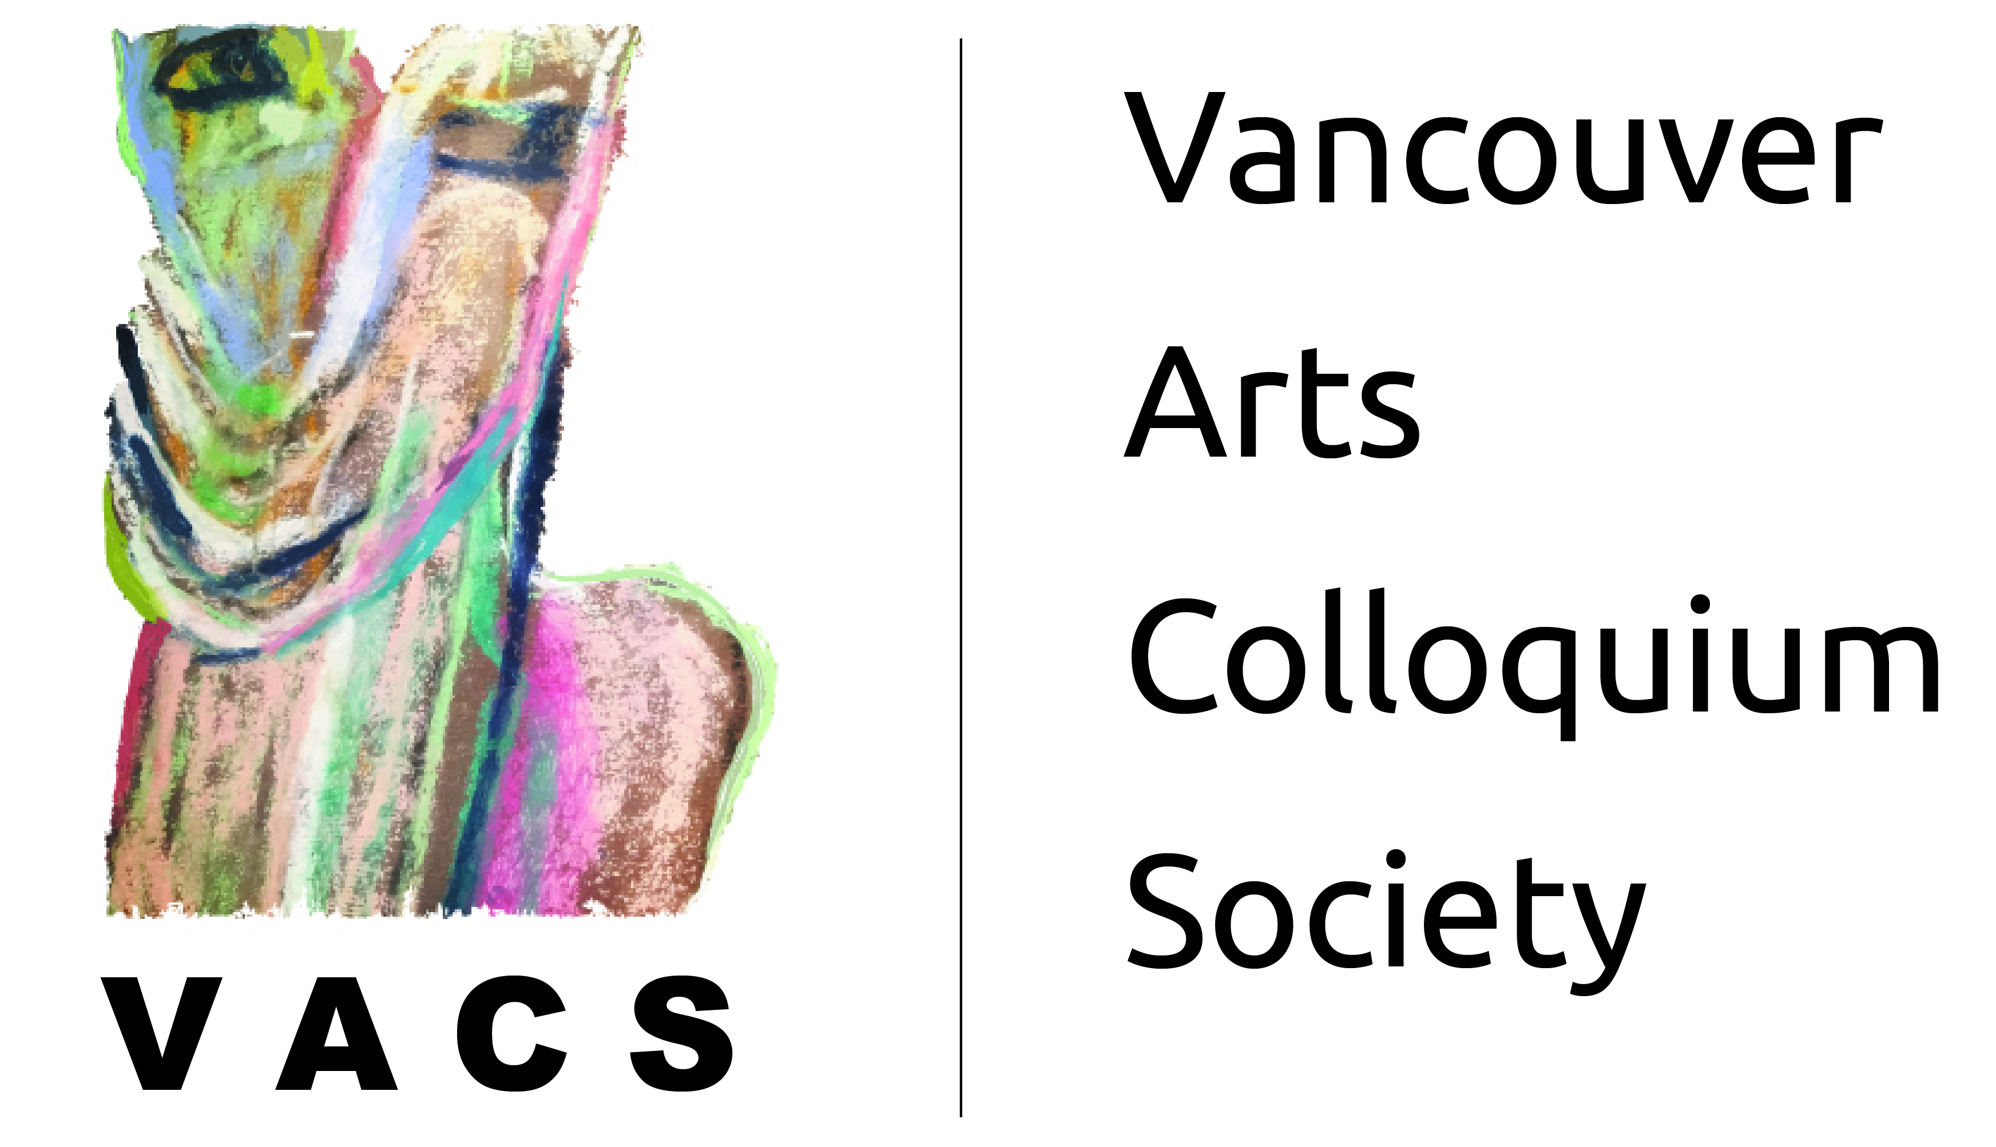
Musical Voice Lab
Participants & Contact Info

First Name | Last Name | E-Mail
Jane | Perrett | jane.perrett.soprano@gmail.com
Susan | Tsang | t.susan20@gmail.com
Jordan | Alexander | ouranian@hotmail.com
Deb | Baldbrelli | deb_baldarelli@hotmail.com
Dellrae | Butler | dellraebutler8500@gmail.com
Gloria | Chiu | chiugloria@hotmail.com
Jennifer | Dowdeswell | jendowdeswell@gmail.com
Maryam | Kashi | mariamkashi@yahoo.com
Farhad | Mirhauy | fmirhady@shaw.ca
Huseyin | Moini | huseyin.moini@gmail.com
Ninan | Pan | ruqing83@hotmail.com
Yulia | Souz | julia_souz@yahoo.com
Christine | Spreter | fuchsc2016@gmail.com
Mimi | Vuong | vuongmm@gmail.com
Mei Lai | Wong | meilaiw@gmail.com
Ruby | Xiang | rubyxiang@gmail.com
Anita | Yin | hoiyin771@gmail.com

